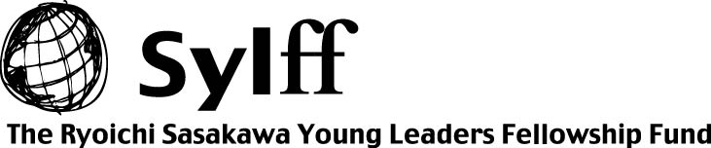

SYLFF Fellows Mobility Program
Application for Funding in FY2008

This form is for SYLFF institutions participating in the SYLFF Fellows Mobility Program (FMP) to apply to The Tokyo Foundation for new funding in fiscal year 2008 (April 1, 2008-March 31, 2009).

Name of SYLFF institution:

Name of SYLFF fellow:

Name of his/her host institution:
*Please attach the SYLFF/FMP Fellow Placement Confirmation issued by the host institution.

His/her period of stay in host institution: From to

Requested amount of funding (up to US$9,000): US$

I certify that the information provided above is correct, and that we will use the fund for sending the above fellow to the host institution mentioned above.

Name and Signature of Chairperson
of the SYLFF Steering Committee:
(Name)

Date:

[NOTE]

- Please send in the application well in advance so that the foundation will have sufficient time to review the documents and undertake administrative procedures.
- The application must be received by January 31, 2009.
- The application must be submitted by the SYLFF institution participating in this program. Individual SYLFF fellows cannot apply directly to the foundation.
- Each institution can submit an application more than once until the total amount of requested funds reaches US$9,000 including the carryover fund, if any, from previous years.
- Submission of the FMP Program and Financial Reports of FY2007 is requested before the application.

This application form is downloadable from the following URL:
http://www.tkfd.or.jp/eng/admin/files/Application%20for%20Funding%20FY2008.doc

